**Task 3**

1. Create a Issue in your github repository.

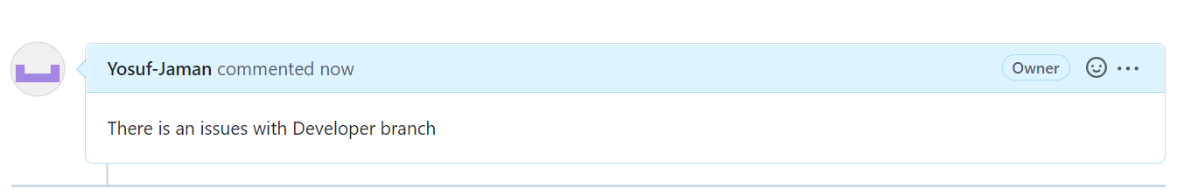

1. Raise a pull request.

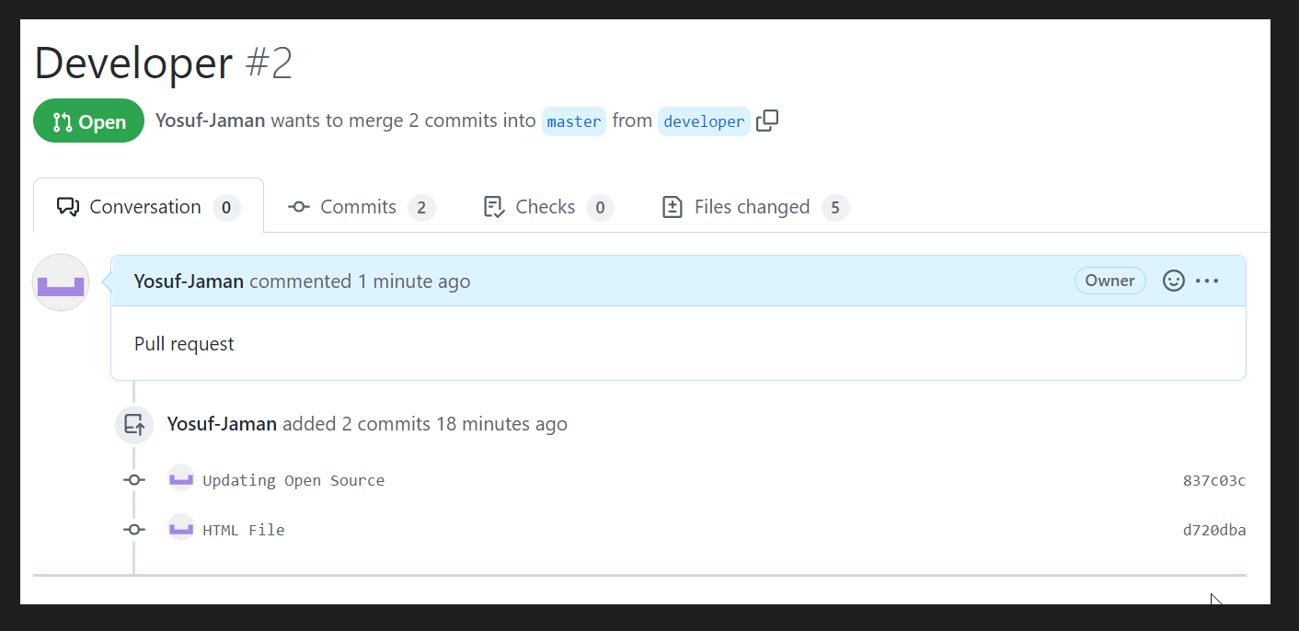

1. Merge a Pull request.

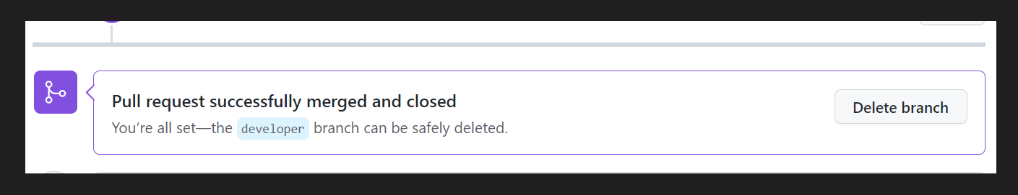

1. Reject a pull request with proper commands.

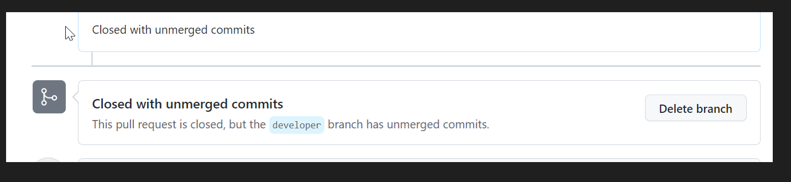

1. Add a Dependabot alerts in your github.(for above cases)

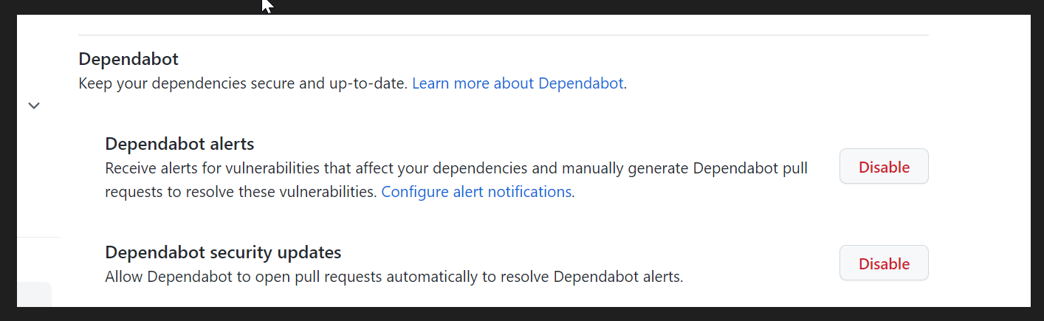

1. Git stash

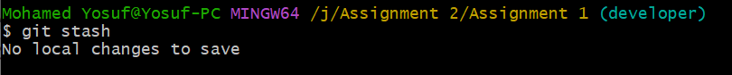

1. Create a release your package

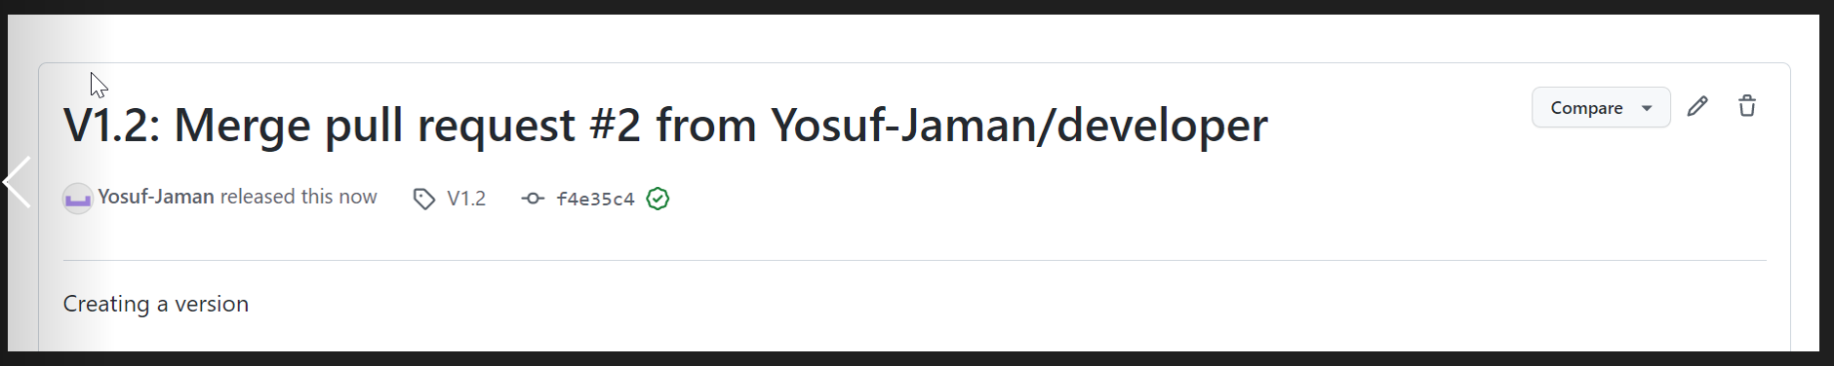

1. Setup a Projects Board for your project.

